**Window Scaling Option :**

It is used to define Receiver window size during a connection between hosts. You can see this option during SYN and SYN/ACK phase of the 3 way handshake.

**1) What is TCP Window size?**

TCP hosts agree to limit the amount of unacknowledged data that can be in transit at any given time.

Example:

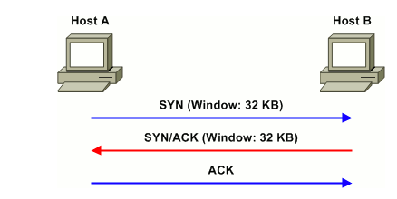

Assuming an MSS of 1460 bytes, host A can transmit 22 segments before exhausting host B's receive window.

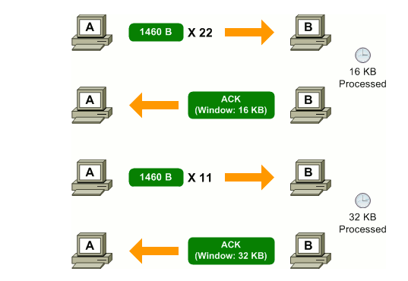

**2) When TCP Window Scaling should be Used ?**

On a LAN with **high bandwidth and extremely low delay**, windows are rarely stressed as there are typically very **few segments** in transit between two endpoints at any given time.

On **a high-bandwidth, high-delay network**, however, an interesting phenomenon occurs: it is possible to **max out the receive window** of the destination host before receiving an acknowledgment.

If you configure send buffer size is 64 k or less , the maximum send buffer size is 64 k, by default is 16 MB.

**BDP:**

Bandwidth * Delay Product determines the amount od data that can be in transit in the network.

It is the product of bandwidth and the latency & **TCP receive window** should be large enough to fit the maximum available bandwidth * maximum anticipated delay(round trip time).

**Note:** When your network BDP is very high you need to use TCP Window scaling to increase the size of your receive window size.

Windows 10 OS supports auto tuning of receive window size but this may cause the problem if intermediate routers does not support.

**3) How to Increase TCP Window Size ?**

* Essentially, window scaling simply extends the **16-bit window field to 32 bits** in length.
* Of course, the engineers could not simply insert an extra 16 bits into the TCP header, which would have rendered it completely incompatible with existing implementations.
* The solution was to define a TCP option to specify a count by which the TCP header field should be [bitwise shifted](http://en.wikipedia.org/wiki/Bitwise_operation#Logical_shift) to produce a larger value.

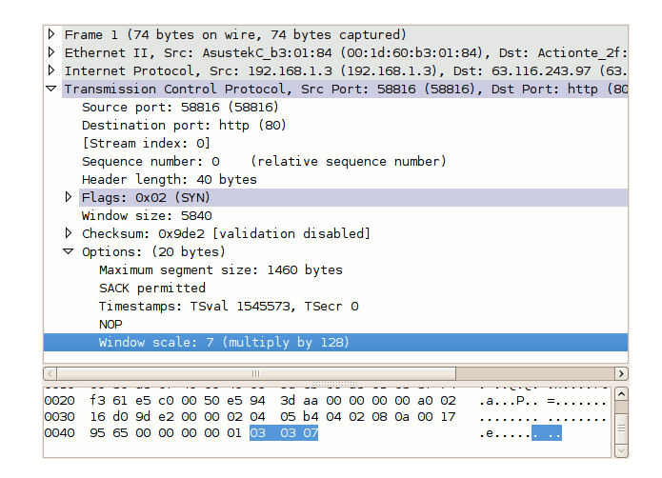

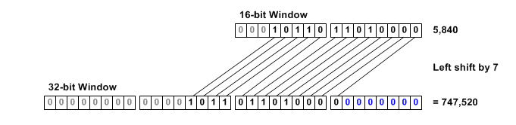

**Note:**

By using the window scale option, the receive window size may be increased up to a maximum value of 1,073,725,440 bytes( means 2**30 and shift count can be 0 to 14).

**4) Configuration:**

Option-Kind (1 byte), Option-Length (1 byte), Option-Data (1 byte).

**Option-Kind** =0x03 ( To indicate the option is of type Window scale option)

**Option-Length=**0x03 ( It is the total length of the Window scale option)

**Option-Data**=0x08 ( It is of 1 byte to represent the number of bits should be left ship done).

This Option should be used at a time of connection establishment only.